Given the head of a singly linked list, reverse the list, and return the reversed list.

Example 1:
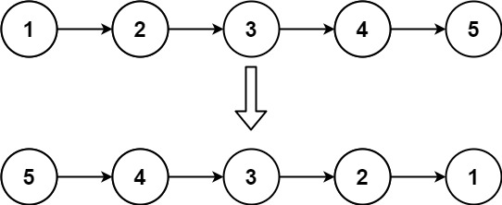
Input: head = [1,2,3,4,5]Output: [5,4,3,2,1]
Example 2:
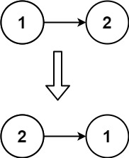
Input: head = [1,2]Output: [2,1]

CODE:
class Solution {
public ListNode reverseList(ListNode head) {
ListNode prev = null;
ListNode curr = head;

while (curr != null) {
ListNode next = curr.next;
curr.next = prev;
prev = curr;
curr = next;
}
return prev;
}
}

